GSLC Survey & Sampling Method
Name: Wilbert Chandra
NIM: 2602113666

- Consider a small population consisting of N = 8 students with the following exam grades:
$$Y_{1}=72, Y_{2}=74, Y_{3}=76, Y_{4}=77, Y_{5}=81, Y_{6}=84, Y_{7}=85, Y_{8}=91$$
- Compute the population mean $\overline{Y}=\frac{1}{N}\sum_{i=1}^{N}{Y_{i}}$
Answer:
$$\overline{Y}=\frac{1}{8}\left(72+74+76+77+81+84+85+91\right)=\frac{555}{8}=80$$
- Compute the population variance $S^{2}=\frac{1}{N-1}\sum_{i=1}^{N}{{\left(Y_{i}-\overline{Y}\right)}^{2}}$
Answer:
$$S^{2}=\frac{1}{8-1}\left({\left(72-80\right)}^{2}+{\left(74-80\right)}^{2}+{\left(76-80\right)}^{2}+{\left(77-80\right)}^{2}+{\left(81-80\right)}^{2}+{\left(84-80\right)}^{2}+{\left(85-80\right)}^{2}+{\left(91-80\right)}^{2}\right)=\frac{288}{7}=41.143$$
- Identify all possible simple random samples of size 2 (There should be 28 possible samples, ignoring the order of selection.) Compute the mean of each possible sample $\overline{y}=\frac{1}{2}\left(y_{1}+y_{2}\right)$ and make a histogram of the sample means.
Answer:
- [72, 74]: y=73.0
- [72, 76]: y=74.0
- [72, 77]: y=74.5
- [72, 81]: y=76.5
- [72, 84]: y=78.0
- [72, 85]: y=78.5
- [72, 91]: y=81.5
- [74, 76]: y=75.0
- [74, 77]: y=75.5
- [74, 81]: y=77.5
- [74, 84]: y=79.0
- [74, 85]: y=79.5
- [74, 91]: y=82.5
- [76, 77]: y=76.5
- [76, 81]: y=78.5
- [76, 84]: y=80.0
- [76, 85]: y=80.5
- [76, 91]: y=83.5
- [77, 81]: y=79.0
- [77, 84]: y=80.5
- [77, 85]: y=81.0
- [77, 91]: y=84.0
- [81, 84]: y=82.5
- [81, 85]: y=83.0
- [81, 91]: y=86.0
- [84, 85]: y=84.5
- [84, 91]: y=87.5
- [85, 91]: y=88.0

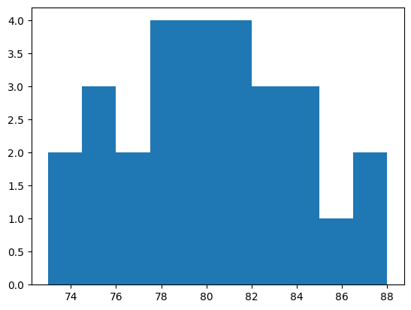

- Compute the sampling variance of the sample means obtained in c) by computing $V\left(\overline{y}\right)=\frac{1}{S}\sum_{s=1}^{S}{{\left({\overline{y}}_{s}-\overline{Y}\right)}^{2}}$, where $S$ is the number of samples of size $n=2$ selected from the $N=8$ elements in the population, and the $s$ subscript represents the different samples. Compare this result to the computed sampling variance $V_{srs}\left(\overline{y}\right)=\frac{1-f}{n}S^{2}$.
Answer:
$$V\left(\overline{y}\right)=\frac{1}{28}\sum_{s=1}^{28}{{\left({\overline{y}}_{s}-\overline{Y}\right)}^{2}}=\frac{1}{28}\left(432.0\right)=15.429$$
$$f=\frac{n}{N}=\frac{2}{8}=\frac{1}{4}=0.25$$
$$V_{srs}\left(\overline{y}\right)=\frac{1-f}{n}S^{2}=\frac{1-0.25}{2}41.143=15.423$$
The sample variance of the sample mean is the same as the computed variance.

- Identify all the possible simple random samples of size n = 6. Compute their means and make a histogram of the sample means.
Answer:

- (72, 74, 76, 77, 81, 84): y=77.333
- (72, 74, 76, 77, 81, 85): y=77.5
- (72, 74, 76, 77, 81, 91): y=78.5
- (72, 74, 76, 77, 84, 85): y=78.0
- (72, 74, 76, 77, 84, 91): y=79.0
- (72, 74, 76, 77, 85, 91): y=79.167
- (72, 74, 76, 81, 84, 85): y=78.667
- (72, 74, 76, 81, 84, 91): y=79.667
- (72, 74, 76, 81, 85, 91): y=79.833
- (72, 74, 76, 84, 85, 91): y=80.333
- (72, 74, 77, 81, 84, 85): y=78.833
- (72, 74, 77, 81, 84, 91): y=79.833
- (72, 74, 77, 81, 85, 91): y=80.0
- (72, 74, 77, 84, 85, 91): y=80.5
- (72, 74, 81, 84, 85, 91): y=81.167
- (72, 76, 77, 81, 84, 85): y=79.167
- (72, 76, 77, 81, 84, 91): y=80.167
- (72, 76, 77, 81, 85, 91): y=80.333
- (72, 76, 77, 84, 85, 91): y=80.833
- (72, 76, 81, 84, 85, 91): y=81.5
- (72, 77, 81, 84, 85, 91): y=81.667
- (74, 76, 77, 81, 84, 85): y=79.5
- (74, 76, 77, 81, 84, 91): y=80.5
- (74, 76, 77, 81, 85, 91): y=80.667
- (74, 76, 77, 84, 85, 91): y=81.167
- (74, 76, 81, 84, 85, 91): y=81.833
- (74, 77, 81, 84, 85, 91): y=82.0
- (76, 77, 81, 84, 85, 91): y=82.333

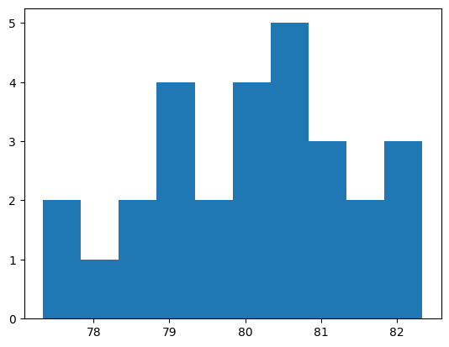

- Using the same population of N = 8 students and exam scores from Exercise 1, consider the stratified population in two groups:
Low Scores: $Y_{11}=72, Y_{12}=74, Y_{13}=76, Y_{14}=77$
High Scores: $Y_{21}=81, Y_{22}=84, Y_{23}=85, Y_{24}=91$
- Identify all possible random samples of size $n=6$ obtained by selecting $n_{h}=3$ from each stratum.
Answer:

- ((72, 74, 76), (81, 84, 85))
- ((72, 74, 76), (81, 84, 91))
- ((72, 74, 76), (81, 85, 91))
- ((72, 74, 76), (84, 85, 91))
- ((72, 74, 77), (81, 84, 85))
- ((72, 74, 77), (81, 84, 91))
- ((72, 74, 77), (81, 85, 91))
- ((72, 74, 77), (84, 85, 91))
- ((72, 76, 77), (81, 84, 85))
- ((72, 76, 77), (81, 84, 91))
- ((72, 76, 77), (81, 85, 91))
- ((72, 76, 77), (84, 85, 91))
- ((74, 76, 77), (81, 84, 85))
- ((74, 76, 77), (81, 84, 91))
- ((74, 76, 77), (81, 85, 91))
- ((74, 76, 77), (84, 85, 91))

- Compute the means from each of the samples identified in part a and make a histogram of the sample means. How does the distribution of these sample means compare with the unstratified version from Exercise 1?
Asnwer:

- ((72, 74, 76), (81, 84, 85)) y=78.667
- ((72, 74, 76), (81, 84, 91)) y=79.667
- ((72, 74, 76), (81, 85, 91)) y=79.833
- ((72, 74, 76), (84, 85, 91)) y=80.333
- ((72, 74, 77), (81, 84, 85)) y=78.833
- ((72, 74, 77), (81, 84, 91)) y=79.833
- ((72, 74, 77), (81, 85, 91)) y=80.0
- ((72, 74, 77), (84, 85, 91)) y=80.5
- ((72, 76, 77), (81, 84, 85)) y=79.167
- ((72, 76, 77), (81, 84, 91)) y=80.167
- ((72, 76, 77), (81, 85, 91)) y=80.333
- ((72, 76, 77), (84, 85, 91)) y=80.833
- ((74, 76, 77), (81, 84, 85)) y=79.5
- ((74, 76, 77), (81, 84, 91)) y=80.5
- ((74, 76, 77), (81, 85, 91)) y=80.667
- ((74, 76, 77), (84, 85, 91)) y=81.167

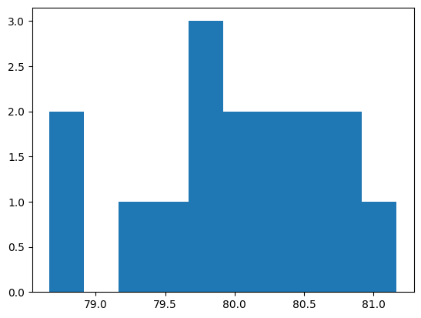

- Calculate the sampling variance of the mean from the stratified sample obtained in part b by computing $V\left(\overline{y}\right)=\frac{1}{S}\sum_{s=1}^{S}{{\left({\overline{y}}_{s}-\overline{Y}\right)}^{2}},$ where $S$ is the number of samples of size $n=6$ selected from the $N=8$ elements in the population.
Answer:
$$V\left(\overline{y}\right)=\frac{1}{16}\sum_{s=1}^{18}{{\left({\overline{y}}_{s}-\overline{Y}\right)}^{2}}=0.469$$
- Compare the result obtained in part c to the computed sampling variance $V\left({\overline{y}}_{st}\right)\sum_{h=1}^{2}{w_{h}^{2}}\frac{1-f_{h}}{n_{n}}$.
$${\overline{y}}_{1}=\frac{1}{4}\left(71+74+76+77\right)=74.75,S_{1}^{2}=\frac{1}{4-1}\left(Y_{1i}-{\overline{y}}_{1}\right)=4.917. f_{1}=\frac{n}{N}=\frac{3}{4}=0.75$$
$${\overline{y}}_{2}=\frac{1}{4}\left(81+84+85+91\right)=85.25,S_{2}^{2}=\frac{1}{4-1}\left(Y_{2i}-{\overline{y}}_{2}\right)=17.583, f_{2}=\frac{n}{N}=\frac{3}{4}=0.75$$
$$V\left({\overline{y}}_{st}\right)=\left[\left({4.917}^{2}\frac{1-0.75}{3}\right)+\left({17.583}^{2}\frac{1-0.75}{3}\right)\right]=27.778$$

- A survey is to be conducted to study work absence due to acute illness in a factory with 1200 workers. Suppose the mean number of days lost per year is 4.6 and that the standard deviation is 2.7 days lost per year, and the sample is to be selected by simple random sampling.
- What sample size is needed to produce an estimate of the mean number of days lost with a standard error of $se\left(\overline{y}\right)=0.15$?
$$n=\frac{\left(1-f\right)s^{2}}{{\left(se\left(\overline{y}\right)\right)}^{2}}=\frac{\left(1-\frac{n}{N}\right)2.7}{{0.15}^{2}}=\frac{2.7-2.7\frac{n}{1200}}{0.0225}=109$$
- Now suppose that a proportionate stratified sample with $H=6$ strata. Formed by the cross-classification pf sex and age (in three age groups) is to be drawn instead. Consider the sample size necessary to achieve a standard error for the mean of $0.15$. Will the sample size for the proportionate stratified design be smaller, the same, or larger than that computed in part a? Briefly explain your answer.
Answer: The sample size of the proportionate stratified sample will likely be smaller than the SRS to achieve the same standard error of 0.15. This is because stratification improves the efficiency of sampling process by focusing on relevant groups.

- The frame for an education survey includes $A=2000$ high school, each containing $B=1000$ students. An epsem sample of $n=3000$ students is selected in two stages. At the first stage, $a=100$ schools are selected randomly, and at the second stage $b=30$ students are selected in each sampled school. Of the selected students, $30\% \left(P=0.3\right)$ reported having access to computers at home. A published estimate gives the standard error of this percentage as $se\left(\overline{y}\right)=1.4\%$. Ignoring finite population corrections and approximation $\left(n-1\right)$ by n, estimate the following:
- The design effect $d^{2}$ for the sample percentage.
Answer:
$$se\left(\overline{y}\right)=\sqrt{V\left(\overline{y}\right)}→V\left(\overline{y}\right)={\left(se\left(\overline{y}\right)\right)}^{2}={0.014}^{2}=0.000196$$
$$V_{srs}\left(\overline{y}\right)=\frac{1-f}{n-1}P\left(1-P\right)→\frac{1}{n}P\left(1-P\right)=\frac{1}{3000}*0.3*0.7=0.00007$$
$$d^{2}=\frac{V\left(\overline{y}\right)}{V_{srs}(\overline{y})}=\frac{0.000196}{0.00007}=2.8$$

- A stratified sample was selected to estimate annual visits to a doctor. The stratum size $\left(N_{h}\right)$, the proportion of the population $\left(W_{h}\right)$, The sample size $(n_{h})$, the sampling fraction $(f_{h})$, the total number of doctor visits $(y_{h})$, the mean number of doctor visits $({\overline{y}}_{h})$, the sample element variance $(S_{h}^{2})$ in each of the three strata are as follows:
Stratum | $$N_{h}$$ | $$W_{h}$$ | $$n_{h}$$ | $$f_{h}$$ | $$y_{h}$$ | $${\overline{y}}_{h}$$ | $$S_{h}^{2}$$
Young | 3200 | 0.40 | 192 | 0.06 | 1152 | 6 | 5
Middle Aged | 4000 | 0.50 | 240 | 0.06 | 1200 | 5 | 4
Old | 800 | 0.10 | 48 | 0.06 | 384 | 8 | 7
Total | 8000 | 1 | 480 | 0.06 | 2736

- Compute the unweighted mean of the strata means.
$$\overline{y}=\frac{6+5+8}{3}=6.333$$
- Compute the weighted stratified mean.
$${\overline{y}}_{st}=0.4*6+0.5*5+0.1*8=5.7$$
- Compute the sampling variance of the mean from part b.
$$V\left({\overline{y}}_{st}\right)=\sum_{h=1}^{3}{W_{h}^{2}*V\left({\overline{y}}_{k}\right)}=W_{1}^{2}\left[\frac{1-f_{1}}{n_{1}}\right]S_{1}^{2}+W_{2}^{2}\left[\frac{1-f_{2}}{n_{2}}\right]S_{2}^{2}+W_{3}^{2}\left[\frac{1-f_{3}}{n_{3}}\right]S_{3}^{2}={0.4}^{2}\left[\frac{1-0.06}{192}\right]5+{0.5}^{2}\left[\frac{1-0.06}{240}\right]4+{0.1}^{2}\left[\frac{1-0.06}{48}\right]7=0.009204$$
- Compute a 95% confidence interval for the mean computed in part b.
$$se\left({\overline{y}}_{st}\right)=\sqrt{V({\overline{y}}_{st})}=\sqrt{0.009204}=0.09594$$
$$95\% Cl→α=0.05$$
$${\overline{y}}_{st}±Z_{1-\frac{α}{2}}*se\left({\overline{y}}_{st}\right)={\overline{y}}_{st}±Z_{0.975}*se\left({\overline{y}}_{st}\right)=5.7±1.96*0.09594=5.7±0.188→[5.512;5.888]$$

